Notes for Coursework for Computing:

V1 – Load of Crap Ignore

V2 - Fully Connected Network, his model consists of just a couple of layers and uses fully connected (dense) layers to make predictions based on the flattened image data. F1 Score of: 0.27389136628267063

V3 – Same as V2 but with an additional hidden layer. F1 Score of : 0.2758334617446431
________________________________________________________________________________
ACTUALLY USEFUL STUFF BELOW:
Feature | Fully Connected Network | Convolutional Neural Network (CNN)
Input Representation | Flattened 1D vector | 2D/3D structure maintained
Spatial Awareness | No | Yes (preserves spatial relationships)
Parameter Count | High (e.g., 224 * 224 * 3 * neurons) | Low (uses shared weights in convolution filters)
Performance on Images | Poor for image tasks | Excellent for image tasks
Application | Tabular data, preprocessed features | Image data, video, and spatially related tasks

V4 – Using a CNN now instead but crap ChatGPT one
F1 Score of: 0.2779987919075722

V5 – CNN Utilising similar code to completed coursework one:
F1 Score of: 0.25154168858791864

V6 – Using exactly her code from the coursework
Score: 0.24827007611839863

V7 – Adding in Focal Loss (our Loss function keeps going down but accuracy decreases)
Score: 0.24758188787958874

V8 – An Additional 4th layer was added
Score: 0.2139362108057063

V10: Accuracy: 29.49

V11:
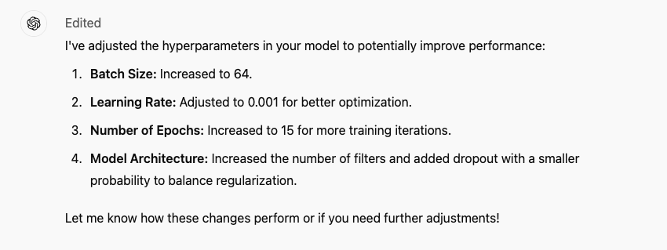
Accuracy: 34.20

V12:
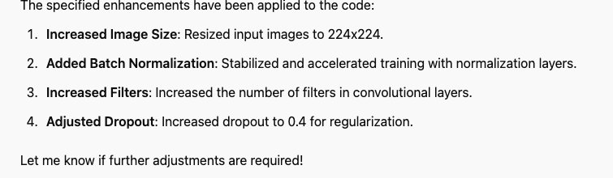
Accuracy: 8% Dog shit

V15:
Added data augmentation techniques to your preprocessing pipeline. The transformations include random horizontal flipping, rotation, and color jittering to improve the model's robustness.
Accuracy: 19.5%

V16:
Added Validation Data to use validation data during training. This includes creating a validation_loader and integrating validation loss and accuracy tracking after each training epoch.

Accuracy: 18.66%

V17: Includes validation, includes more filters and additionally fully connected layers, increased dropout as well and added graphs at the end to print out the information
Accuracy:

V18: The same as before but only uses the 5 classifications with the most number of training images
Accuracy: 34.6%

V19: The code has been updated with the following changes:
Data Preprocessing Enhancements: Added random horizontal flipping, random rotation, and colour jitter for data augmentation. Normalized the image tensors with typical ImageNet means and standard deviations for better training stability.
Learning Rate Adjustment: Reduced the learning rate to 0.0005 to allow finer updates and improve convergence.

Accuracy: 34.86

V20: Increased number of epochs to 50 from 15
Accuracy: 41%

V21: Increased number of epochs to 100 from 50
Accuracy: 43%, it levels out and doesn’t have any increase, keep it at 50

V22: added a learning rate scheduler (torch.optim.lr_scheduler.StepLR) to your training process.
Accuracy: 39%

V23: Added batch normalisation and returned the learning rate back to optim. Adam
Accuracy: 41%

